# OUTPUT SCREEN

**STEP 1:**- MAIN MENU SCREEN

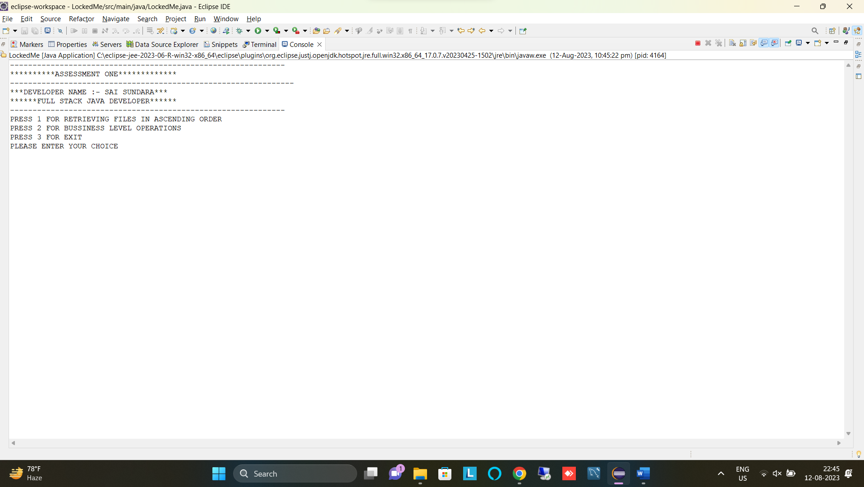

**STEP 2:**- FOR SHOWING FILES IN ASCENDING ORDER

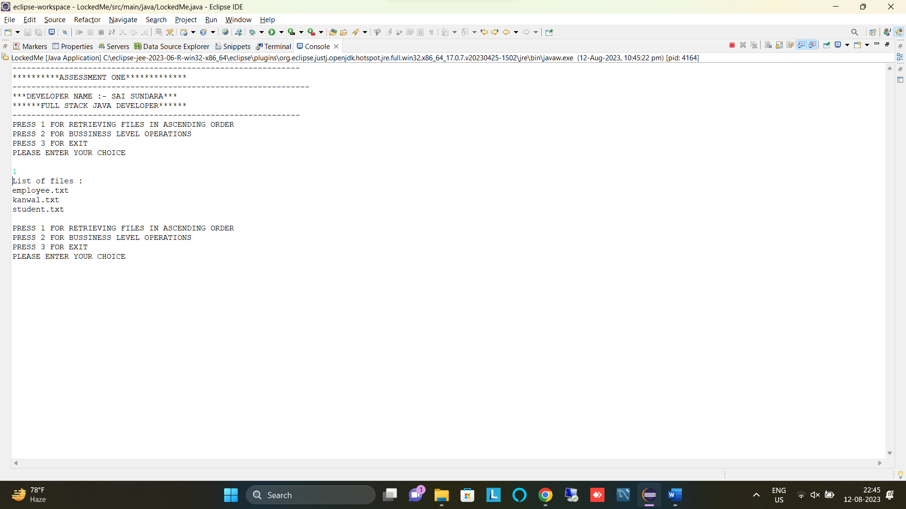

**STEP 3:**- FOR BUSSINESS LEVEL OPERATION

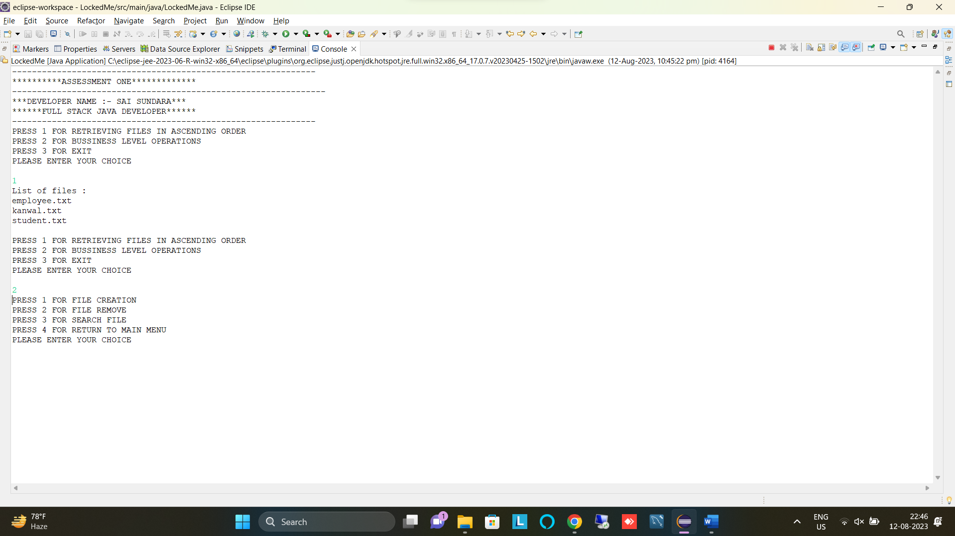

**STEP 3:**- FOR BUSSINESS LEVEL OPERATION

A:-1 FOR FILE CREATION

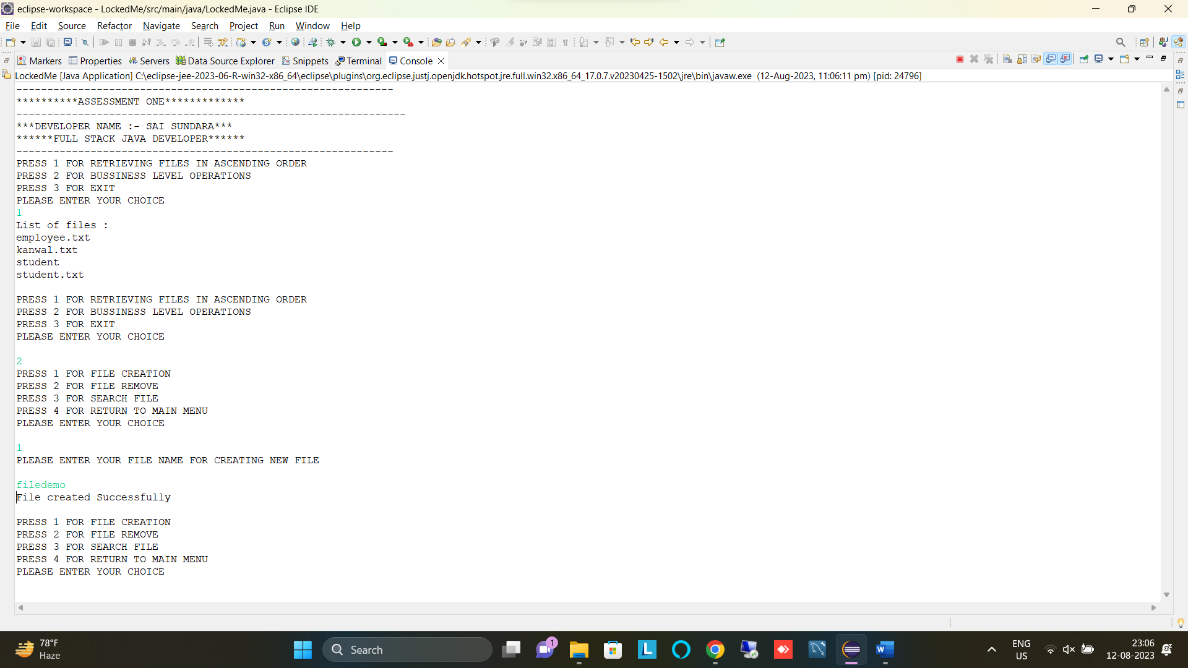

B:-2 FOR FILE DELETION

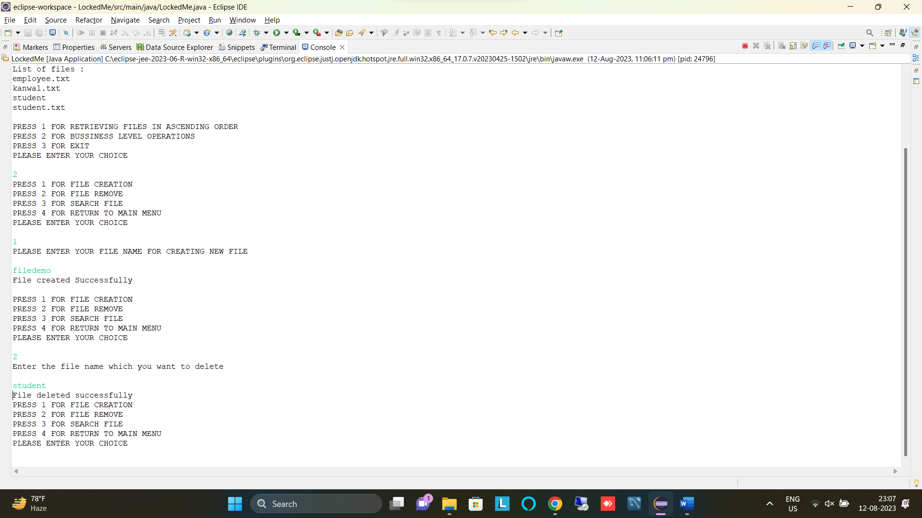

C:-3 FOR SEARCH A FILE

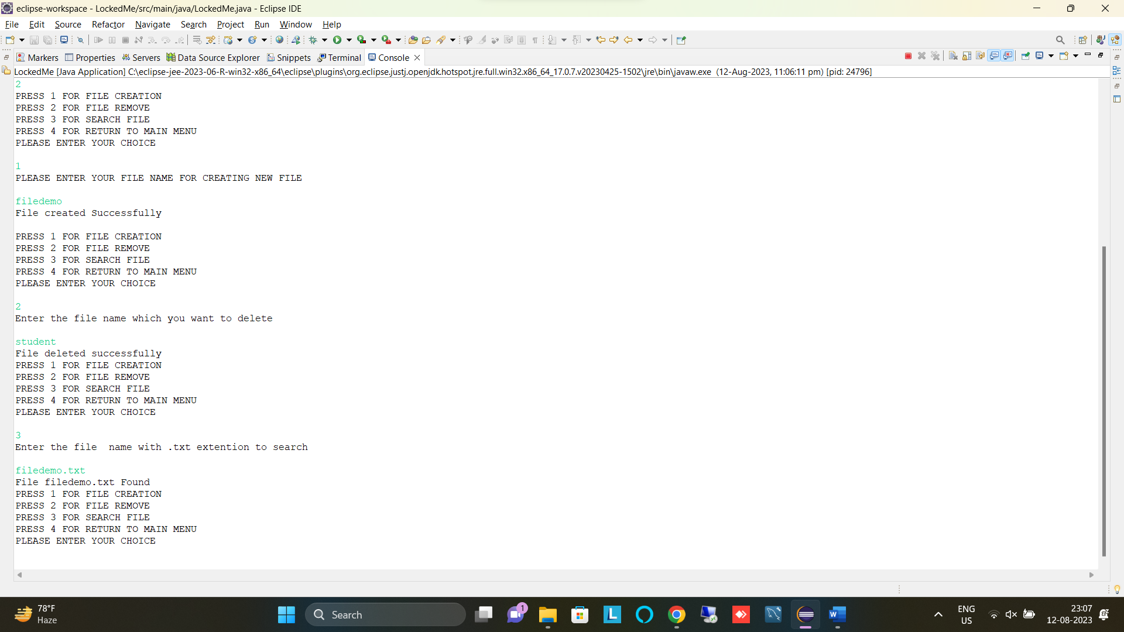

D:-4 FOR RETURN TO MAIN MENU

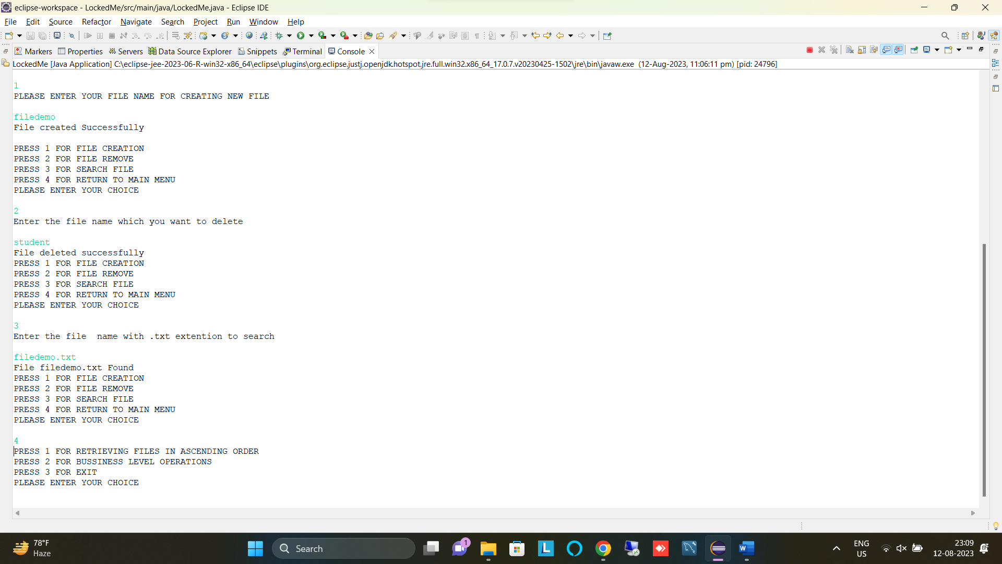

**STEP 3:**- FOR EXIT THE PROJECT

